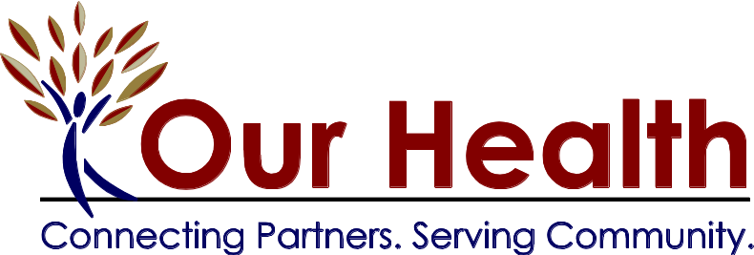

FOR IMMEDIATE RELEASE

Contact:
Sharen Gromling, Executive Director, Our Health
sgromlin@valleyhealthlink.com
540.536.1601

Adult Care Center, NSV and City Housing Department Joins Our Health Campus

Winchester, VA (December 15, 2011)-Our Health, Inc. and its North Cameron Properties partners are pleased to announce the addition of two new agencies to the Kendall Community Campus. The Adult Care Center, NSV (ACC) which provides day services to older adults suffering from dementia and Alzheimer’s have entered a 6 year lease for the first floor and a portion of the second floor of the Snapp Foundry Building, 411 North Cameron Street. They are currently making a few building modifications to the space to allow the clients a large activity room and hope to move in the first of the year. Our Health Board Chair John Capehart said, “Our Health is pleased to have this well-respected non-profit move onto our campus and join the other health and public service agencies. We look forward to serving them and their wonderful clients.” The ACC hopes to expand its capacity from 27 to 45 clients served daily through this move. Joining them at 411 North Cameron Street is the City of Winchester’s Housing Department. They have entered a 15 year lease for a group of offices on the second floor of the building, leaving approximately 1,000 square feet of the original 40,000 square feet to lease. Executive Director Sharen Gromling, the Our Health Board and staff have been working hard since the Snapp Foundry Building was opened in 2010 to lease the remaining space. Gromling stated, “Because of the current economic conditions, leasing the space has been challenging, but we believe that the benefits of being on this non-profit health and human services campus are what convinced these agencies to sign leases.”

With the addition of the ACC and Housing, the Kendall Community Campus expands to thirteen agencies (which includes the Our Health administrative offices). Other campus agencies include Clarke-Frederick-Winchester Foster Care; Child Advocacy Center of Winchester and Frederick County; Concern Hotline, Inc.; Dental Clinic of NSV; Free Medical clinic of NSV; Healthy Families, NSV; Literacy Volunteers of the Winchester Area; Lord Fairfax Health Department; United Way, NSV; and the Winchester Department of Social Services. It is estimated that these agencies provide more than 30,000 client services each year to those most in need in our community. The co-location of these agencies in this centrally located downtown area with bus transportation, allows clients to reduce the number of trips by coordinating visits with multiple non-profits.

Our Health is a non-profit community organization founded by Valley Health Systems, Inc. which supports agencies in the Northern Shenandoah Valley. Incorporated in 1999, an idea became a reality when a collaborative location became home for several area agencies in downtown Winchester. The campus was further expanded in 2010 when key public service agencies moved into the historically renovated Snapp Foundry Building which was designed to LEED silver standards. Our Health continues to create opportunities which elevate community involvement and commitments to the region. Its Volunteer Action Center provides viable services to connect agencies with area volunteers and enhance programs. In addition, Our Health provides grant writing and administration and training and technical assistance for its more than 45 non-profit partners.

“Our Health – Connecting Partners, Serving Community”

329 N. Cameron St., Suite 200 ● Winchester, VA 22601● Phone 540-536-1600 ● Fax 540-536-0192
www.ourhealthva.org ● www.ohvolunteeractioncenter.org

